**COMPILER DESIGN**

LAB-2

**Sandra Maria Tony**

**RA1911026010045**

**K1**

**Aim:**

Conversion of Regular Expression to Non Deterministic Finite Automata

**Procedure:**

1. Open the compiler
2. Write the code
3. Compile the code
4. Execute the code
5. Verify the output.

**Source Code:**

#include<stdio.h>

#include<string.h>

int main()

{

char reg[20];

int q[20][3],i,j,len,a,b;

for(a=0;a<20;a++)

{

for(b=0;b<3;b++)

{

q[a][b]=0;

}

}

scanf("%s",reg);

len=strlen(reg);

i=0;

j=1;

while(i<len)

{

if(reg[i]=='a'&&reg[i+1]!='|'&&reg[i+1]!='*')

{

q[j][0]=j+1;

j++;

}

if(reg[i]=='b'&&reg[i+1]!='|'&&reg[i+1]!='*')

{

q[j][1]=j+1;

j++;

}

if(reg[i]=='e'&&reg[i+1]!='|'&&reg[i+1]!='*')

{

q[j][2]=j+1;

j++;

}

if(reg[i]=='a'&&reg[i+1]=='|'&&reg[i+2]=='b')

{

q[j][2]=((j+1)*10)+(j+3);

j++;

q[j][0]=j+1;

j++;

q[j][2]=j+3;

j++;

q[j][1]=j+1;

j++;

q[j][2]=j+1;

j++;

i=i+2;

}

if(reg[i]=='b'&&reg[i+1]=='|'&&reg[i+2]=='a')

{

q[j][2]=((j+1)*10)+(j+3);

j++;

q[j][1]=j+1;

j++;

q[j][2]=j+3;

j++;

q[j][0]=j+1;

j++;

q[j][2]=j+1;

j++;

i=i+2;

}

if(reg[i]=='a'&&reg[i+1]=='*')

{

q[j][2]=((j+1)*10)+(j+3);

j++;

q[j][0]=j+1;

j++;

q[j][2]=((j+1)*10)+(j-1);

j++;

}

if(reg[i]=='b'&&reg[i+1]=='*')

{

q[j][2]=((j+1)*10)+(j+3);

j++;

q[j][1]=j+1;

j++;

q[j][2]=((j+1)*10)+(j-1);

j++;

}

if(reg[i]==')'&&reg[i+1]=='*')

{

q[0][2]=((j+1)*10)+1;

q[j][2]=((j+1)*10)+1;

j++;

}

i++;

}

printf("Transition function \n");

for(i=0;i<=j;i++)

{

if(q[i][0]!=0)

printf("\n q[%d,a]-->%d",i,q[i][0]);

if(q[i][1]!=0)

printf("\n q[%d,b]-->%d",i,q[i][1]);

if(q[i][2]!=0)

{

if(q[i][2]<10)

printf("\n q[%d,e]-->%d",i,q[i][2]);

else

printf("\n q[%d,e]-->%d & %d",i,q[i][2]/10,q[i][2]%10);

}

}

return 0;

}

**CODE SCREENSHOT:**

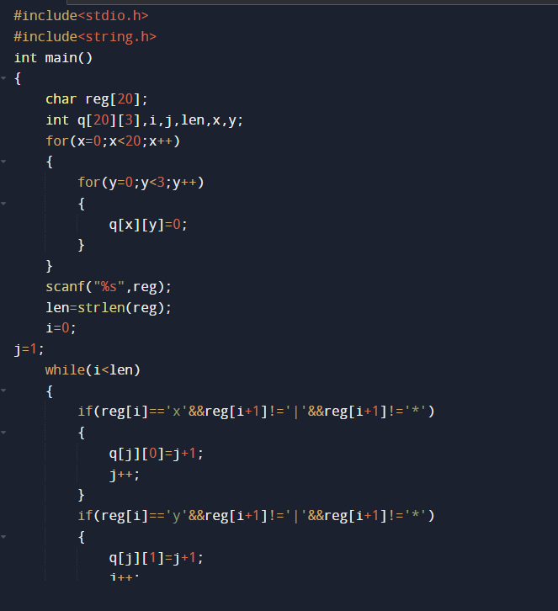

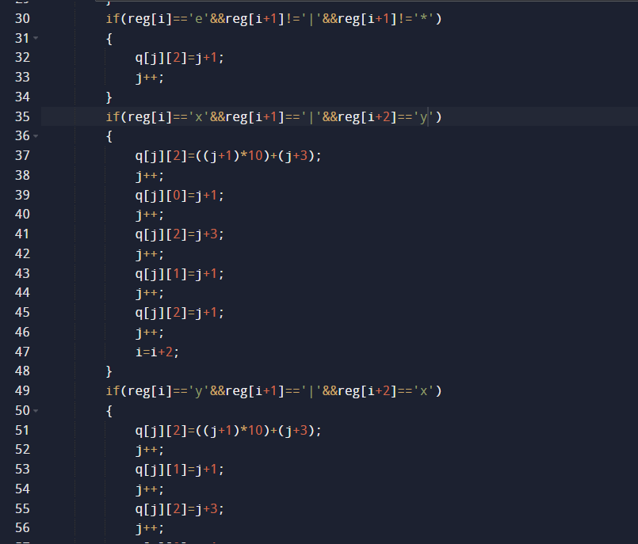

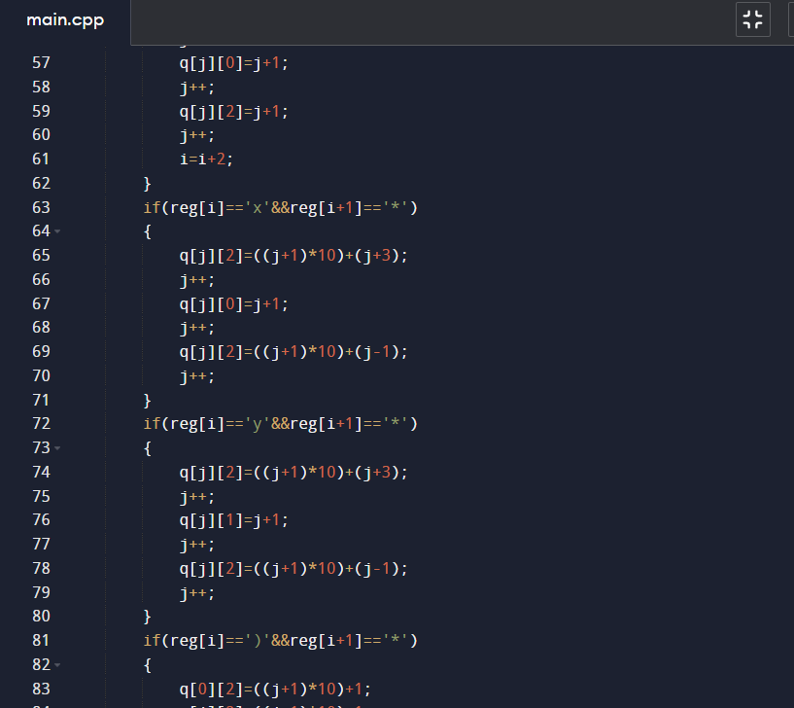

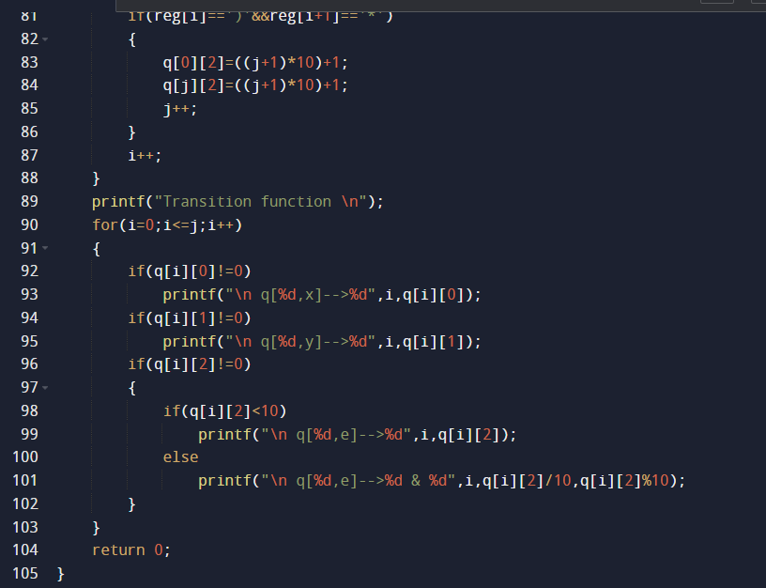

**OUTPUT SCREENSHOT:**

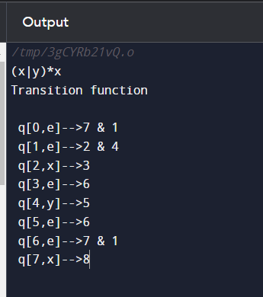

**TRANSITION TABLE:**

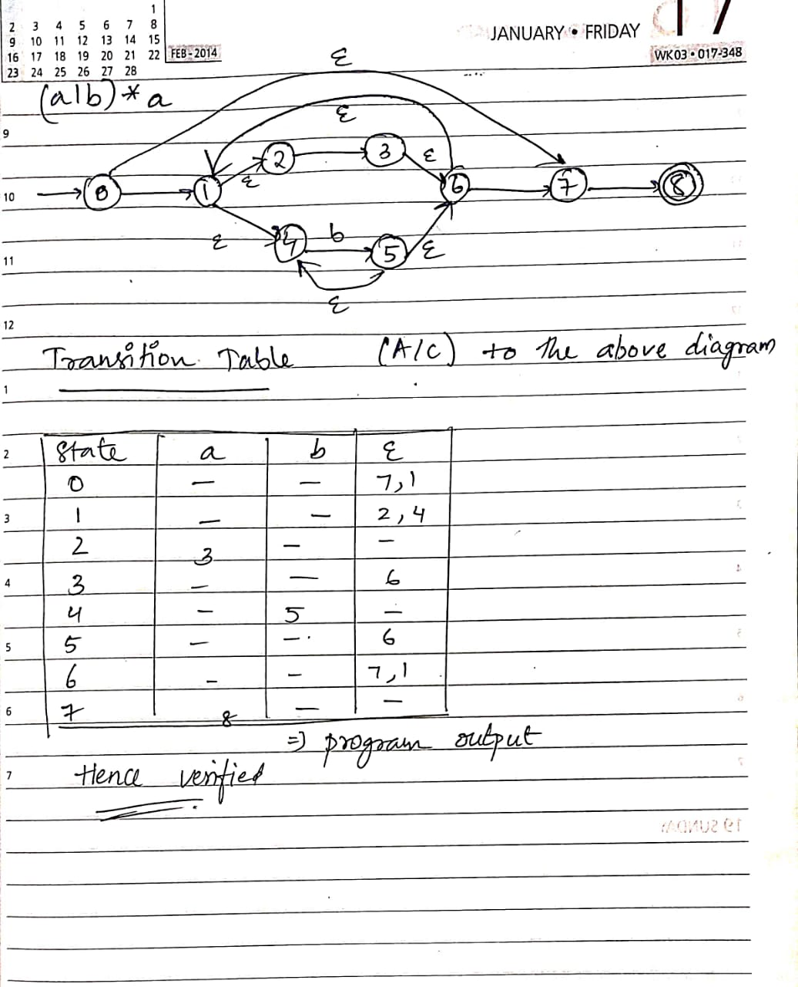

**CONCLUSION :**

The transition in both the cases is true. Hence conversion of Regular Expression to Non Deterministic Finite Automata was executed successfully.